Airbnb Providers
On-Demand Home Services in Kathmandu

Prepared for: Sriyog Consulting
Prepared by: Sadikshya Karki

Date: June 2026
Research Scope: Kathmandu, Nepal

1. Introduction
Kathmandu, the capital city of Nepal, has witnessed considerable growth in short-term rental accommodations over the past decade. Airbnb has become one of the most widely used platforms for travellers seeking local and affordable stays in the city. This report presents an analysis of 90 Airbnb providers operating in Kathmandu, examining their host type, hosting experience, number of reviews, and ratings. The purpose of this analysis is to understand the overall quality and diversity of Airbnb providers in the city and to identify patterns that distinguish Superhosts from regular Hosts.

2. Dataset Overview
The dataset used in this analysis consists of 90 Airbnb providers identified in Kathmandu. Each provider was reviewed to determine the following information:
- Provider name
- Host Type classification (Superhost or Host)
- Hosting Duration
- Total number of reviews received
- Overall rating on the platform
Table 1: Airbnb Providers
Providers | Host Type | Hosting Time | Reviews | Ratings
Kash | Superhost | 11 Months | 76 | 4.91
Kopila | Superhost | 14 Years | 430 | 4.88
Subu and Mala | Superhost | 11 Years | 473 | 4.88
Nara | Superhost | 2 Years | 303 | 4.91
Mila | Superhost | 3 Years | 42 | 4.98
Ashmit | Superhost | 2 Years | 146 | 4.93
Dhana | Superhost | 2 Years | 71 | 4.93
Subash | Superhost | 8 Months | 52 | 5
Gaurab | Superhost | 10 Months | 52 | 4.98
Arjan | Host | 7 Years | 341 | 4.68
Shaili | Superhost | 1 Year | 38 | 4.87
Rara | Superhost | 2 Years | 47 | 5
Prabina | Host | 2 Years | 8 | 5
Jason Jenish Emi and Tisa | Superhost | 7 Years | 63 | 4.97
Tashi | Superhost | 9 Years | 303 | 4.88
Babin | Superhost | 3 Years | 189 | 4.89
Ketan | Superhost | 7 Years | 201 | 4.84
Michi | Host | 2 Months | 4 | 5
Beth and Anjesh | Superhost | 8 Years | 140 | 4.94
Casa Deyra | Superhost | 8 Years | 546 | 4.74
Nigen Sohan Rojen | Superhost | 13 Years | 2731 | 4.93
Jamuna | Superhost | 4 Years | 28 | 4.96
Anup | Superhost | 7 Years | 137 | 4.95
The White House Villa | Superhost | 4 Years | 19 | 4.79
Rahul | Host | 5 Months | 4 | 5
Neeti | Superhost | 10 Years | 25 | 4.96
Rohan | Superhost | 11 Months | 39 | 4.95
Tenzin | Superhost | 5 Months | 12 | 4.92
Shazia | Superhost | 6 Years | 882 | 4.95
Raju | Host | 1 Month | 3 | 5
Ayush | Superhost | 3 Years | 77 | 4.92
Cindy | Host | 3 Years | 19 | 4.84
Devraj | Host | 4 Years | 42 | 4.6
Bishnu | Host | 1 Month | 3 | 4.67
Sudarshan | Host | 4 Years | 15 | 4.93
Prajol | Superhost | 5 Months | 51 | 4.98
Kalpana | Host | 4 Months | 10 | 5
Anu | Host | 1 Month | 5 | 5
A La Mode Studio | Superhost | 10 Years | 44 | 4.86
Sita | Host | 9 Years | 79 | 4.86
Cozy Ghar | Superhost | 1 Year | 132 | 4.91
Renjen | Host | 8 Months | 1 | 5
Naoko Laxmi Rai | Superhost | 10 Years | 91 | 4.99
Shivaram | Host | 9 Years | 152 | 4.74
Anjali | Host | 2 Years | 20 | 4.85
Sabina | Host | 1 Month | 1 | 5
Family Apartment | Host | 8 Months | 6 | 4.5
Meena | Host | 2 Months | 4 | 5
Pralhad | Host | 7 Months | 3 | 5
Salvi and Family | Superhost | 2 Years | 31 | 4.94
Sweet Dream Apartment Kathmandu Nepal | Host | 8 Years | 28 | 5
Salil | Host | 6 Months | 5 | 5
Umesh | Superhost | 1 Year | 5 | 5
Anil | Superhost | 6 Years | 158 | 4.96
Deepak | Host | 10 Months | 47 | 4.91
Pooja | Superhost | 2 Years | 34 | 4.85
Eleena Sabin | Superhost | 2 Years | 185 | 4.92
Pranab | Superhost | 5 Months | 21 | 5
Ashu | Superhost | 2 Years | 42 | 4.83
Dr. AJ | Host | 10 Years | 4 | 4.75
Akki | Host | 5 Months | 6 | 5
Abhijit | Host | 2 Years | 3 | 5
Zenhaus Apartment | Superhost | 7 Years | 10 | 5
Shristi | Host | 8 Years | 45 | 4.13
Pravin | Superhost | 3 Years | 27 | 4.93
Krenjila | Host | 3 Months | 23 | 4.96
Gaurav | Host | 9 Years | 28 | 4.93
Sagar | Host | 4 Years | 6 | 5
Janga | Host | 7 Years | 22 | 4.91
Naba | Superhost | 3 Years | 57 | 4.96
Urgen | Superhost | 1 Year | 36 | 4.86
Dinesh | Superhost | 8 Years | 162 | 4.93
Nikita | Host | 1 Month | 1 | 5
Aman | Host | 6 Months | 2 | 5
Ambar | Host | 7 Years | 36 | 4.92
Aashraya Jyoti | Host | 2 Years | 23 | 4.78
Pratima | Host | 6 Years | 34 | 4.91
Sunny | Superhost | 2 Years | 48 | 4.92
Eten | Superhost | 9 Years | 75 | 4.61
Anand | Host | 2 Years | 24 | 4.92
Prerana | Host | 3 Years | 27 | 5
Jeevan | Superhost | 9 Months | 17 | 4.76
Akash Ratna | Superhost | 9 Years | 178 | 4.84
Pranam | Host | 2 Years | 50 | 4.74
Ishan | Superhost | 4 Years | 48 | 4.96
Chalet Stays | Host | 2 Years | 22 | 4.64
Amir | Host | 3 Years | 14 | 5
Prakriti | Superhost | 8 Years | 45 | 4.78
Sanjay Kumar | Superhost | 10 Months | 10 | 4.8
Amulya | Host | 3 Years | 15 | 4.6

3. Summary Statistics
Out of 90 providers, 49 hold the Superhost designation, which accounts for 54 percent of the total. The remaining 41 providers are classified as regular Hosts, making up 46 percent. Superhosts are recognized by Airbnb for consistently maintaining high ratings, completing a minimum number of stays, and demonstrating strong responsiveness to guests.
Table 2: Summary Statistics of Airbnb Providers in Kathmandu
Metric | Value
Total Providers Analyzed | 90
Total Superhosts | 49
Total Hosts | 41
Average Rating (All) | 4.891
Average Rating Superhost | 4.907
Average Rating Host | 4.872
Average Reviews (All) | 109.0
Average Reviews Superhost | 176.1
Average Reviews Host | 28.9
Providers with Perfect 5.0 Rating | 24
Highest Review Count | 2731

4. Host Type Analysis
The distribution of host types in Kathmandu reveals that more than half of the analyzed providers have achieved Superhost status. This suggests that a strong culture of hospitality and guest satisfaction exists among Kathmandu-based Airbnb providers. The slight majority of Superhosts over regular Hosts indicates that many providers in the city are serious about maintaining standards on the platform.
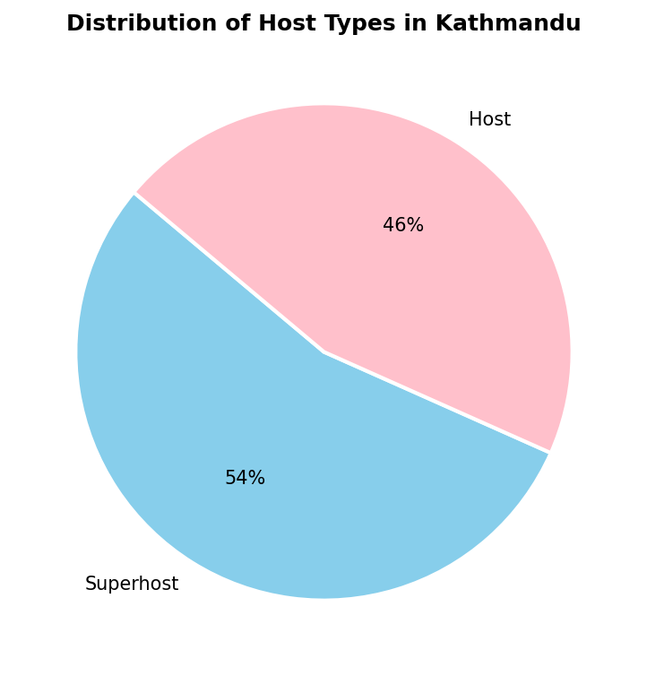
Figure 1: Distribution of Host Types in Kathmandu
The pie chart above clearly illustrates the near-even split between the two categories, with Superhosts holding a modest but meaningful lead. This balance reflects a maturing market where both experienced and newer hosts are active on the platform.

5. Rating and Review Analysis

Ratings
Ratings are one of the most important indicators of guest satisfaction on Airbnb. Across all 90 providers in Kathmandu, the average rating stands at 4.891 out of 5.0, which is notably high. This reflects the overall quality of hospitality offered by providers in the city. A total of 24 providers has achieved a perfect rating of 5.0, demonstrating exceptional performance.
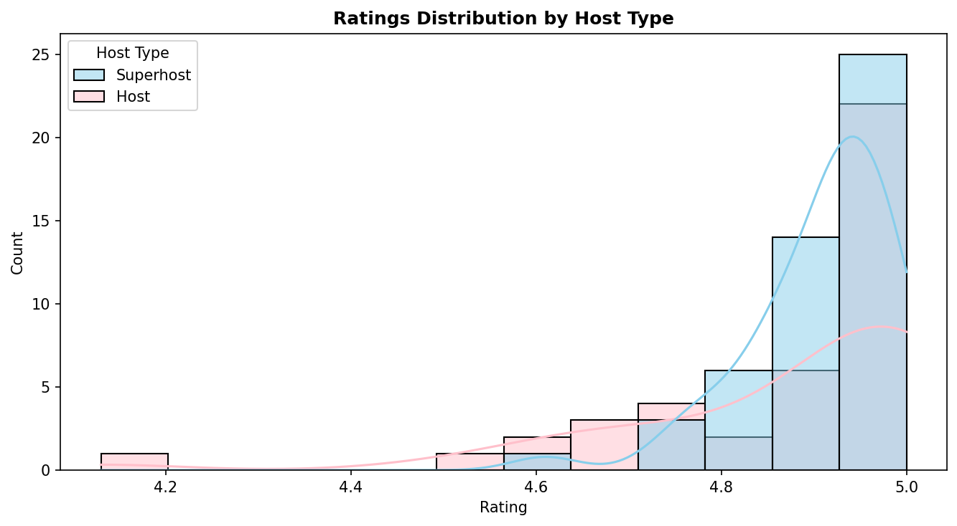
Figure 2: Ratings Distribution by Host Type
The distribution of ratings shows that most providers are clustered between 4.8 and 5.0, with very few falling below 4.6. Superhosts tend to be concentrated at the higher end of the rating scale, while regular Hosts show slightly more variation. The lowest rating recorded in the dataset is 4.13, belonging to a provider named Shristi, which remains above the platform average globally.

Reviews
The number of reviews a provider has received is a strong indicator of activity and trustworthiness on the platform. Providers with more reviews are generally perceived as more reliable by potential guests. In this dataset, the overall average number of reviews is 109.0, though this figure is heavily influenced by a small number of high-review providers.
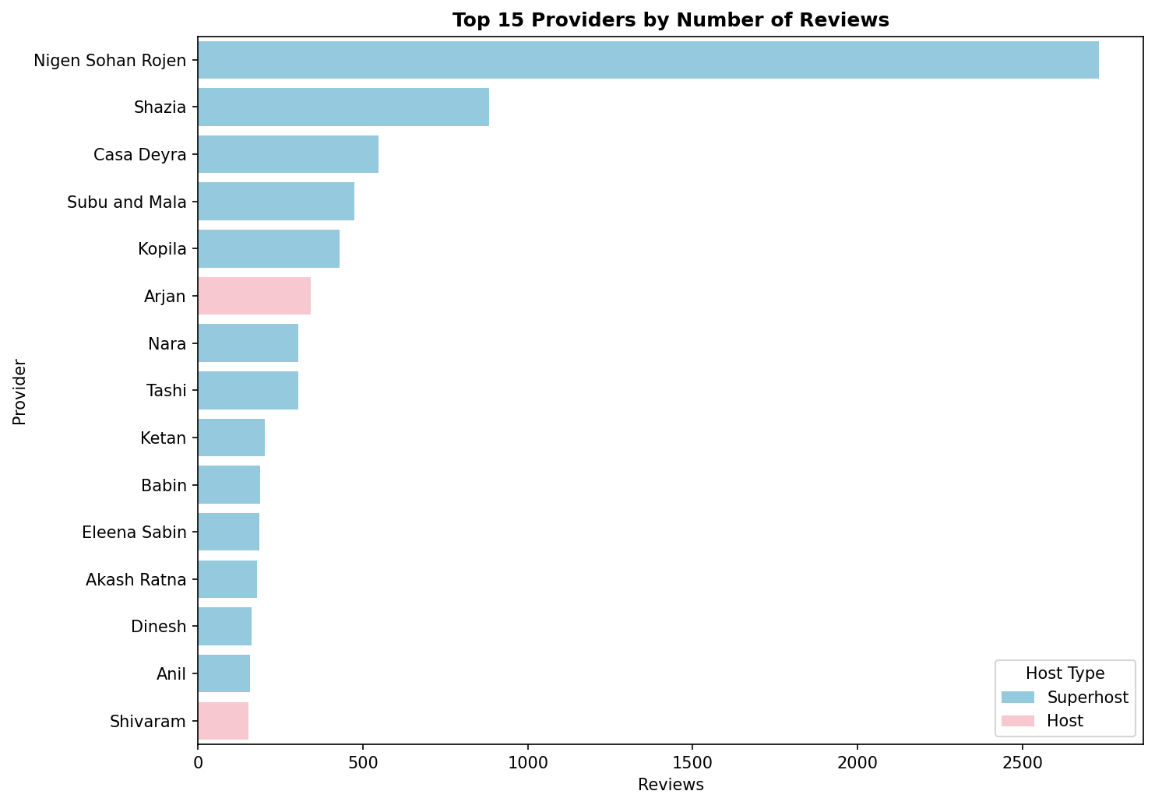
Figure 3: Top 15 Providers by Number of Reviews
The top-ranked provider by reviews is Nigen Sohan Rojen with 2,731 reviews, which is more than three times higher than the second-ranked provider Shazia, who has 882 reviews. Both are Superhosts, which reinforces the relationship between experience and recognition. Casa Deyra, Subu and Mala, and Kopila round out the top five, all of whom are also Superhosts with long hosting histories. The dominance of Superhosts in the top 15 strongly indicates that consistent performance leads to greater guest engagement over time.

Ratings and Reviews
When comparing average ratings, Superhosts score 4.907 on average while regular Hosts score 4.872. Although the difference appears small, it is consistent with Airbnb criteria that require Superhosts to maintain a high rating threshold over multiple stays. More notably, the average number of reviews for Superhosts is 176.1, compared to just 28.9 for regular Hosts. This significant gap suggests that Superhosts are not only more experienced but also considerably more active and popular on the platform.
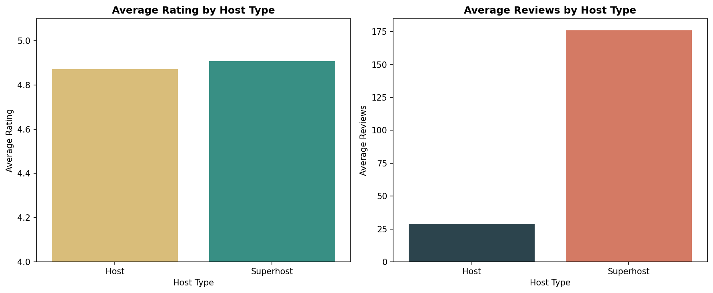
Figure 4: Average Rating and Average Reviews by Host Type

6. Relationship Between Reviews and ratings
Understanding whether providers with more reviews tend to have higher or lower ratings can provide useful insights into how experience shapes quality. A scatter plot of all 90 providers reveals interesting patterns in this regard.
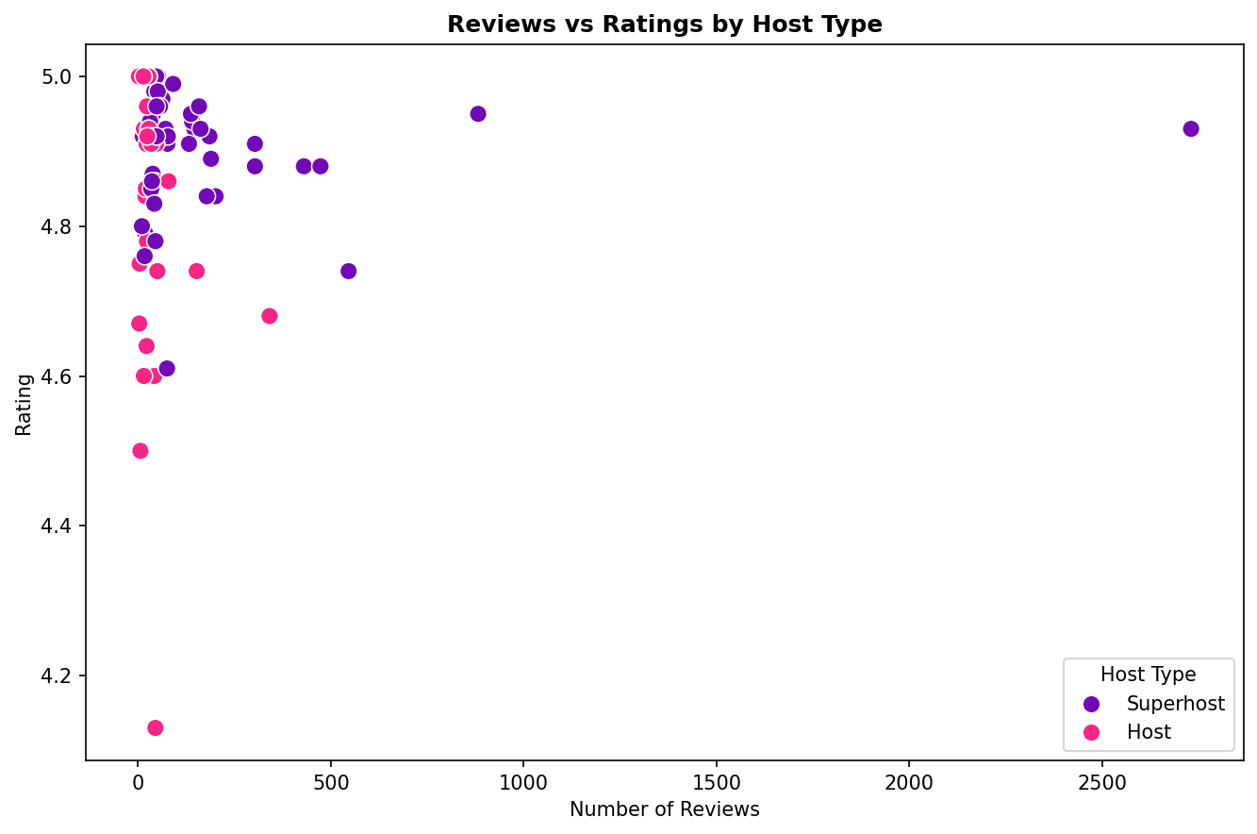
Figure 5: Reviews vs Ratings Scatter Plot by Host Type
The scatter plot shows that most providers with fewer reviews are spread across a wide range of ratings, including both very high and slightly lower scores. Providers with very high review counts, such as Nigen Sohan Rojen, still maintain excellent ratings above 4.9. This suggests that high volume does not lead to a decline in quality for experienced hosts. The correlation between reviews and ratings in this dataset is weak, meaning that having more reviews does not guarantee a higher rating, but consistently high-performing providers do tend to accumulate more reviews over time.

7. Hosting Experience and Tenure
The hosting duration of providers varies considerably across the dataset, ranging from providers who joined only one month ago to those with over 14 years of experience. To better understand the distribution, providers were grouped into five experience tiers based on their total months of hosting.
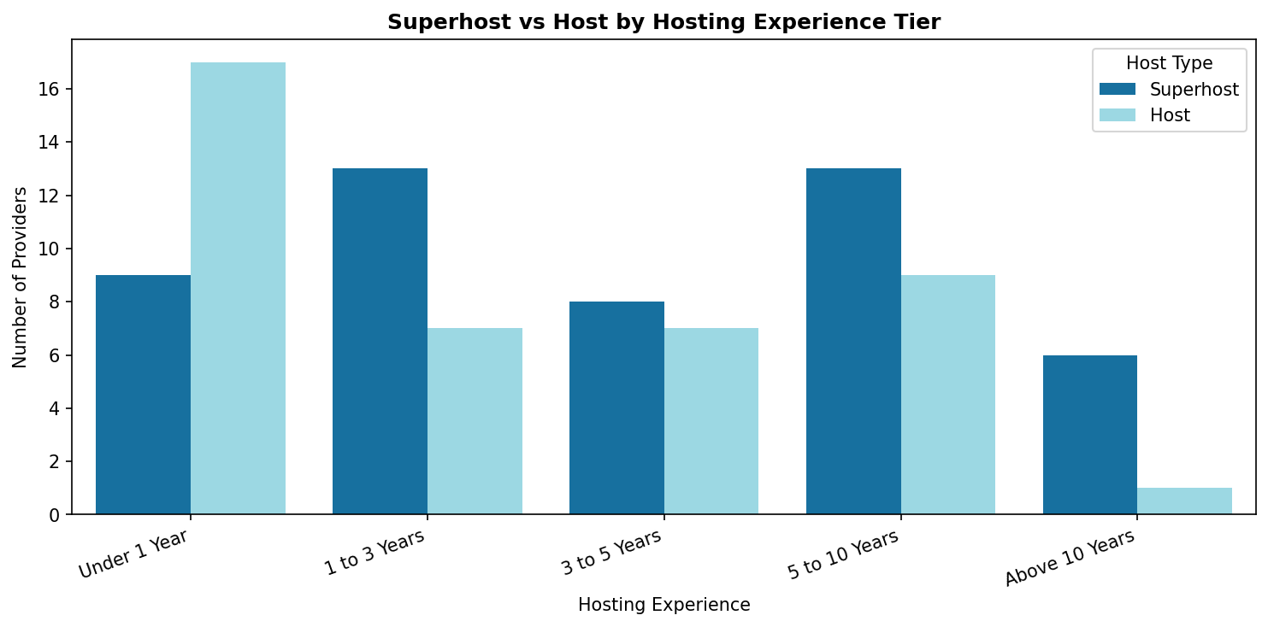
Figure 6: Superhost vs Host Distribution by Hosting Experience Tier
Among providers with less than one year of experience, regular Hosts outnumber Superhosts, which is expected since the Superhost status requires a minimum period of activity and performance. As the experience tier increases to one to three years and five to ten years, Superhosts begin to dominate clearly. This pattern strongly supports the idea that sustained effort and longevity on the platform are key factors in achieving and maintaining Superhost status. The tier with the fewest providers overall is above 10 years, where only seven providers exist, six of whom are Superhosts.

8. Conclusion
This analysis of 90 Airbnb providers in Kathmandu reveals a market that is largely driven by experienced and high-quality hosts. Most providers hold Superhost status, and the average rating across all providers is exceptionally high at 4.891. Superhosts significantly outperform regular Hosts in terms of review volume, reflecting greater trust and popularity among guests.
The data also shows that hosting experience plays a meaningful role in achieving Superhost recognition. Providers who have been active for several years are far more likely to hold Superhost status compared to newer entrants. The top providers by review count are exclusively Superhosts, suggesting that a commitment to quality over time is rewarded with greater visibility and bookings on the platform.
Overall, Kathmandu presents a vibrant and competitive Airbnb market. New hosts entering the space would benefit from focusing on guest satisfaction from the very beginning, as consistent quality appears to be the clearest path toward long-term success and Superhost recognition on the platform.

